
PES University, Bangalore
(Established under Karnataka Act N0.16 of 2013)

JACK FRUIT MINI PROJECT REPORT
ON
“INCOME TAX CALCULATOR AND STOCK TRACKER”

Submitted by
TEAM | NAME | SRN
Member-1 | Akshay Swamy S B | PES1UG25CS047
Member-2 | Abhinav B Raju | PES1UG25EC009
Member-3 | Athmiya M | PES1UG25EC055
Member-4 | Bhuvan Y A | PES1UG25AM077

(Aug-Jan 2025-26)

Under the guidance of
Miss. ANJUSHREE K
Asst. Prof
Department of CSE
PES university

Problem Statement
Individuals often struggle with calculating their taxes accurately and tracking stock prices efficiently. Many tools are either too complex or require web frameworks.
This project aims to build a simple, desktop-based Python application that:
- Computes income tax using user-defined slabs and deductions.
- Fetches real-time stock prices and displays them along with candlestick-style graphs.
Provides an intuitive and minimalistic GUI built using wxPython
Approach / Methodology
The development of the Personal Finance Manager followed a modular and incremental approach. The application was designed by first identifying core functional modules such as user authentication, tax calculation, stock tracking, and data persistence. Each module was implemented independently and later integrated into a unified graphical user interface using wxPython.
The workflow begins with user authentication, where credentials are validated against stored records. Upon successful login, the user is presented with a dashboard and sidebar-based navigation. Each feature is loaded dynamically without restarting the application, ensuring smooth transitions between modules.
The tax calculation module applies slab-based logic for both the Old and New tax regimes. User inputs are validated, processed, and stored for future reference. Stock tracking uses simulated data to visualize price trends using line graphs. Data persistence is achieved using CSV files to maintain simplicity and transparency.
Testing was conducted at each stage to ensure correctness, stability, and consistency of outputs. The final integration focused on maintaining UI responsiveness and data integrity.
Methodology
- Requirement Analysis
Functional and non-functional requirements were identified, focusing on usability, accuracy, and data persistence.
- System Design
The application was divided into logical modules such as Login, Tax Calculator, Stock Tracker, Watchlist, and Account Management.
- Implementation
Each module was coded using Python with wxPython for GUI, Matplotlib for data visualization, and ReportLab for PDF generation.
- Testing
Unit-level testing and user-level testing were performed to validate calculations, file handling, and UI behavior.
- Deployment
The final application was packaged as a standalone Python program suitable for desktop execution.
Data Structures Used
- Dictionary
Used to store tax deductions and stock base prices.
Example:
  - DEDUCTIONS stores deduction limits under different sections.
  - STOCKS stores base prices of stocks.
- Lists
Used for storing rows of CSV data, tax history records, and simulated stock price history.
- CSV Files
Used as persistent storage for:
  - User credentials
  - Tax history
  - Stock watchlist
- Strings and Numeric Types
Used extensively for user input, tax calculations, and financial values.
Sample Input and Output
Sample Input 1: Tax Calculation
Input
- Annual Income: 800000
- Tax Regime: Old Regime
- Deductions Selected: 80C, 80D
Processing
- Total Deductions: 175000
- Taxable Income: 625000
Output
- Base Tax: 25000
- Cess (4%): 1000
- Final Tax Payable: 26000
Sample Input 2: Stock Tracker
Input
- Selected Stock: TCS
Output
- Current Price Displayed: ₹97
- Line graph showing last 10 price fluctuations
Sample Input 3: Login
Input
- Username: user123
- Password: pass123
Output
- Successful login and redirection to dashboard
Challenges Faced
- GUI Layout Management
Designing a clean and responsive interface using wxPython required careful handling of sizers and layout adjustments.
- Data Persistence
Managing multiple CSV files for different users while ensuring data consistency was challenging.
- Dynamic UI Updates
Switching between panels without reloading the application required precise control of widget destruction and recreation.
- PDF Generation
Formatting tabular tax data into a readable PDF layout using ReportLab required fine-tuning of spacing and pagination.
- Error Handling
Validating user inputs and handling incorrect or missing data gracefully was essential to avoid runtime crashes.
Scope for Improvement
- Database Integration
Replacing CSV files with a relational database such as MySQL or SQLite would improve scalability and security.
- Real-Time Stock Data
Integration of live stock market APIs would make the stock tracker more realistic and useful.
- Enhanced Security
Implementing password hashing and encryption instead of plain-text storage.
- Improved UI Design
Incorporating modern UI themes, animations, and responsive layouts.
- Analytics and Insights
Adding financial insights, tax-saving recommendations, and graphical summaries.
- Cross-Platform Packaging
Converting the application into a standalone executable using tools like PyInstaller.

SCREEN SHOTS OF THE EXECUTABLE CODE WITH OUTPUT
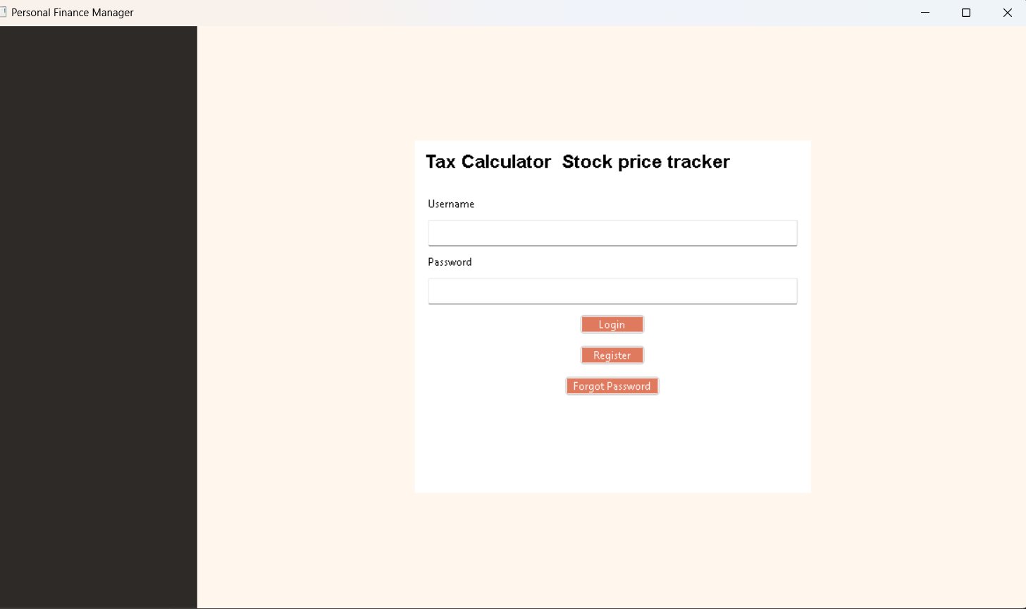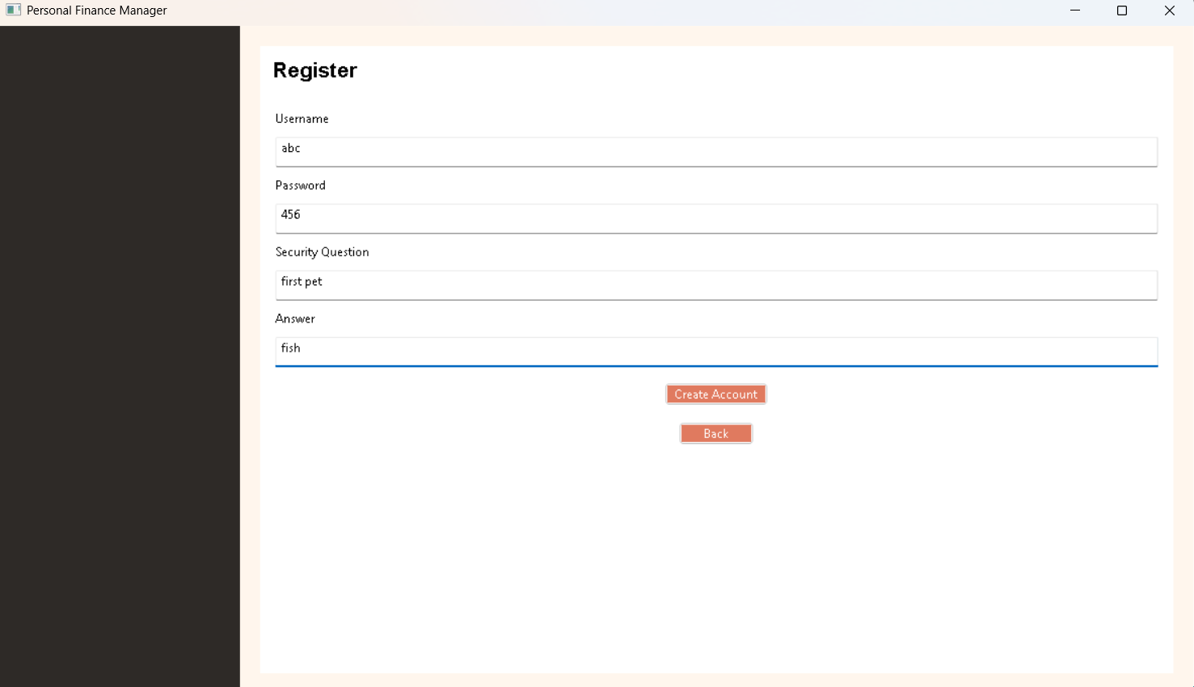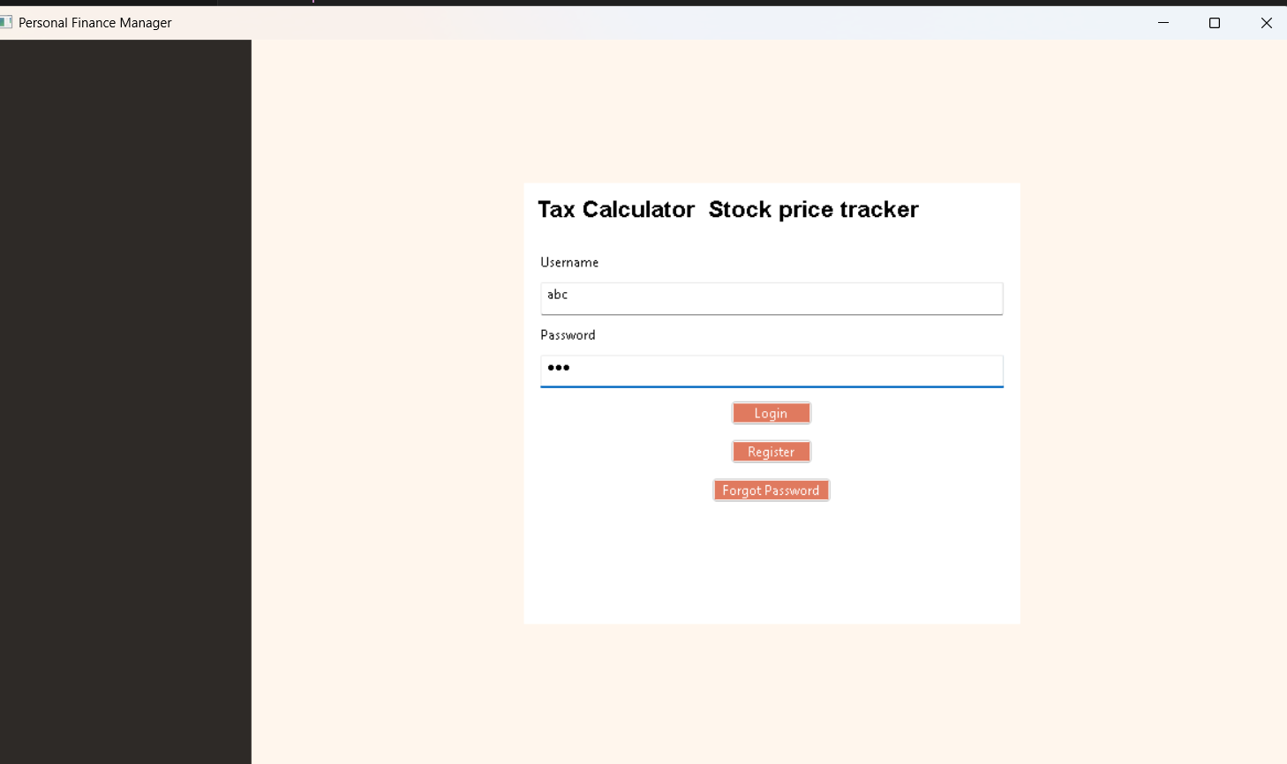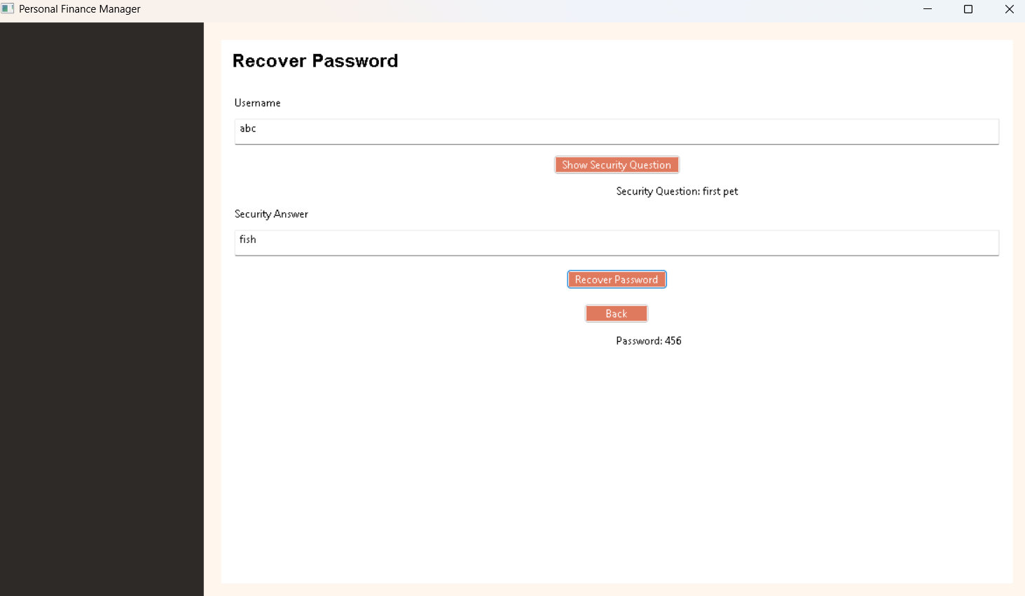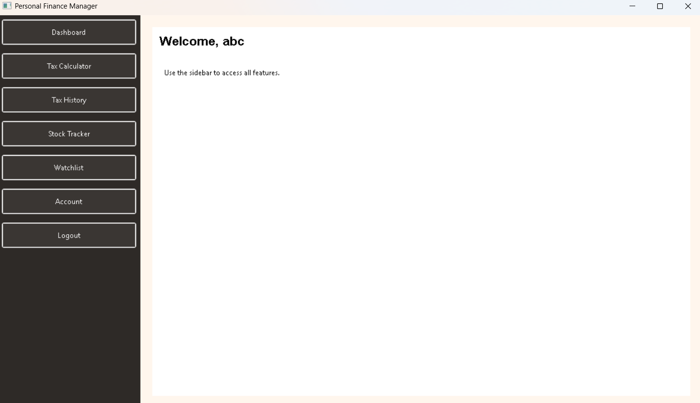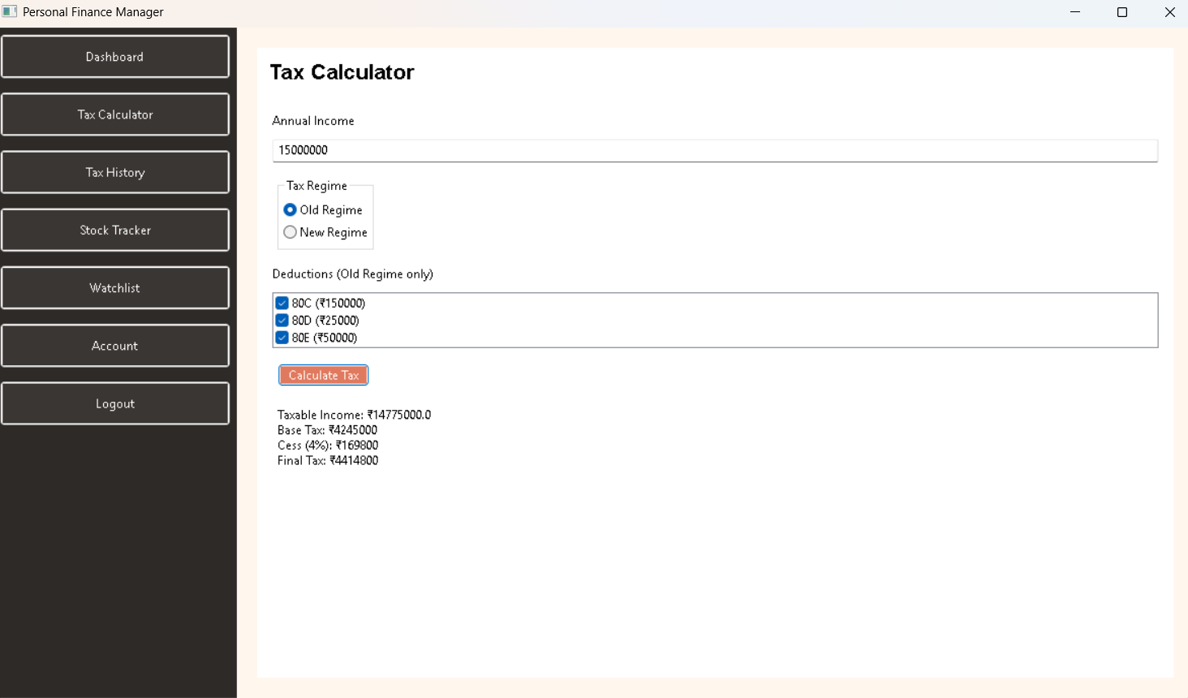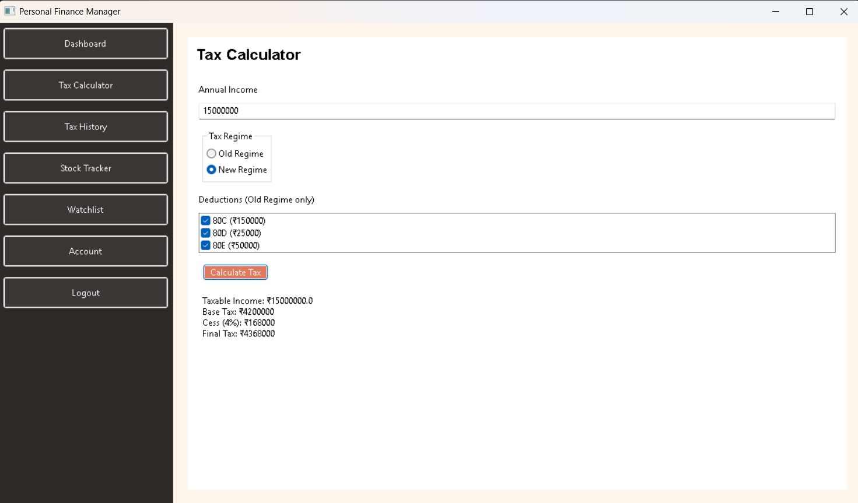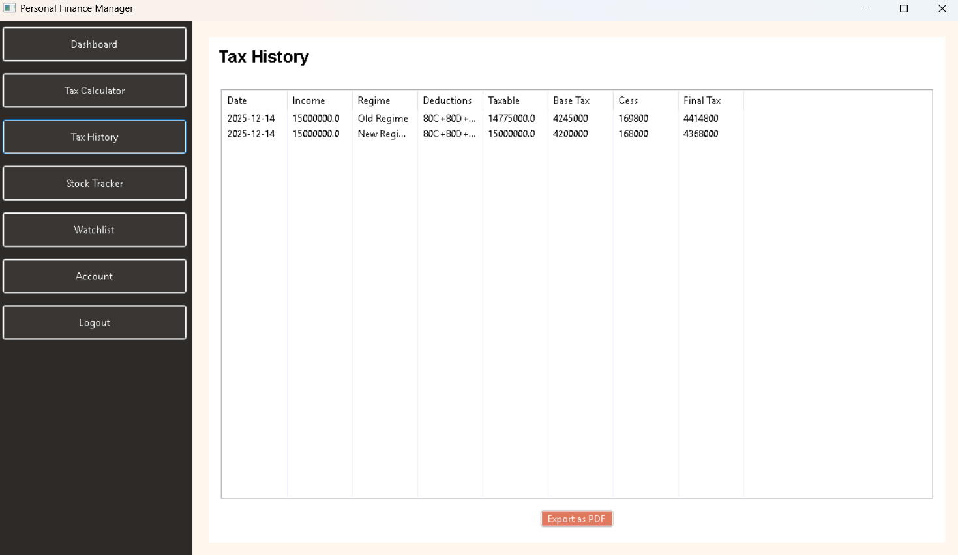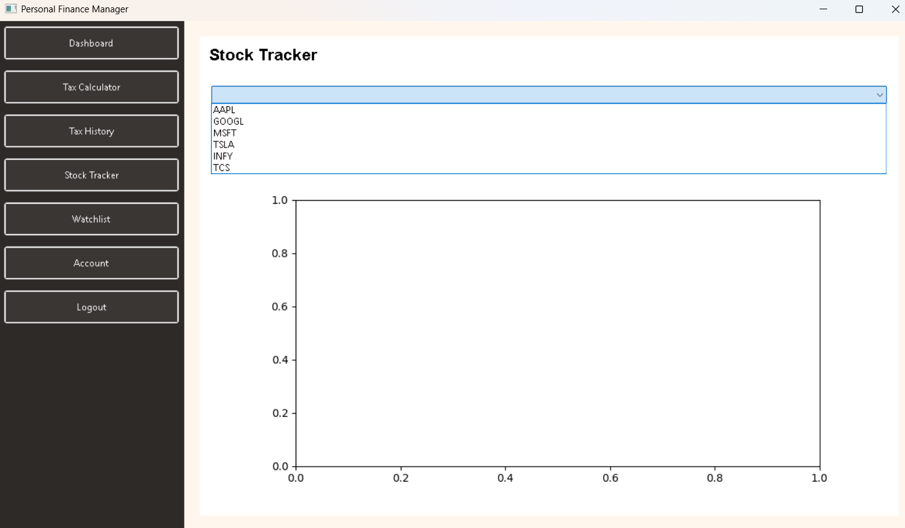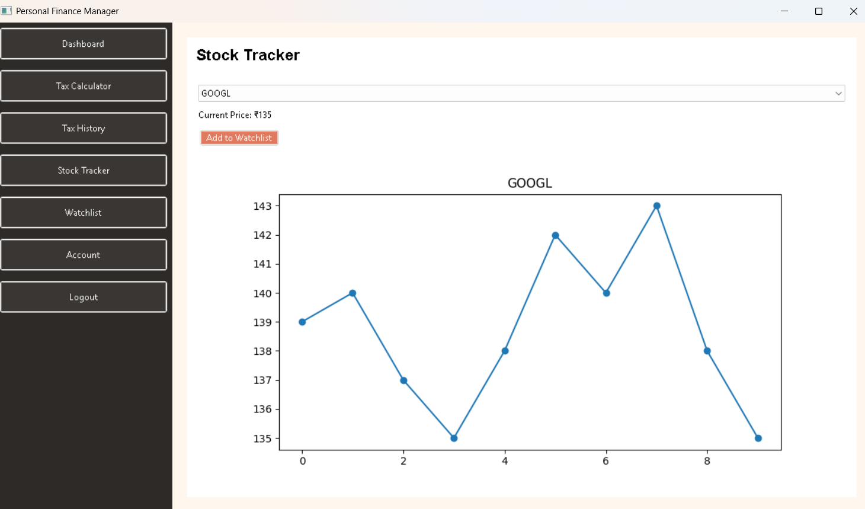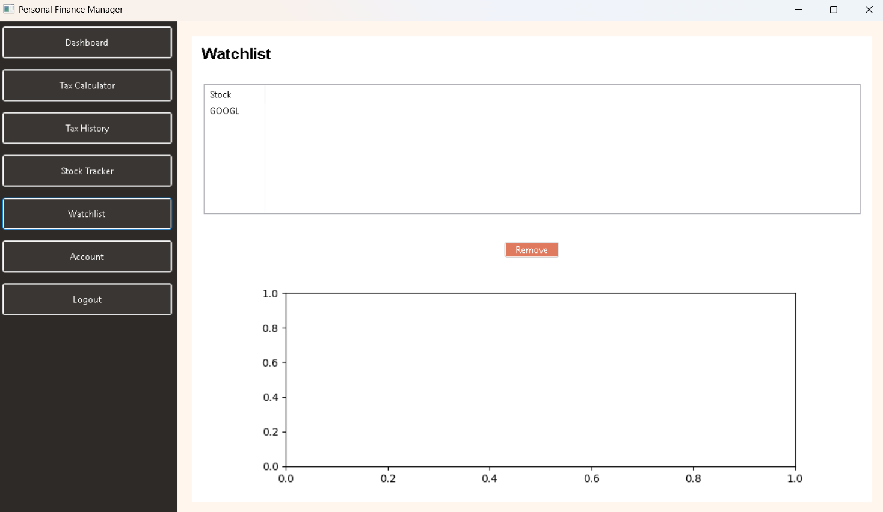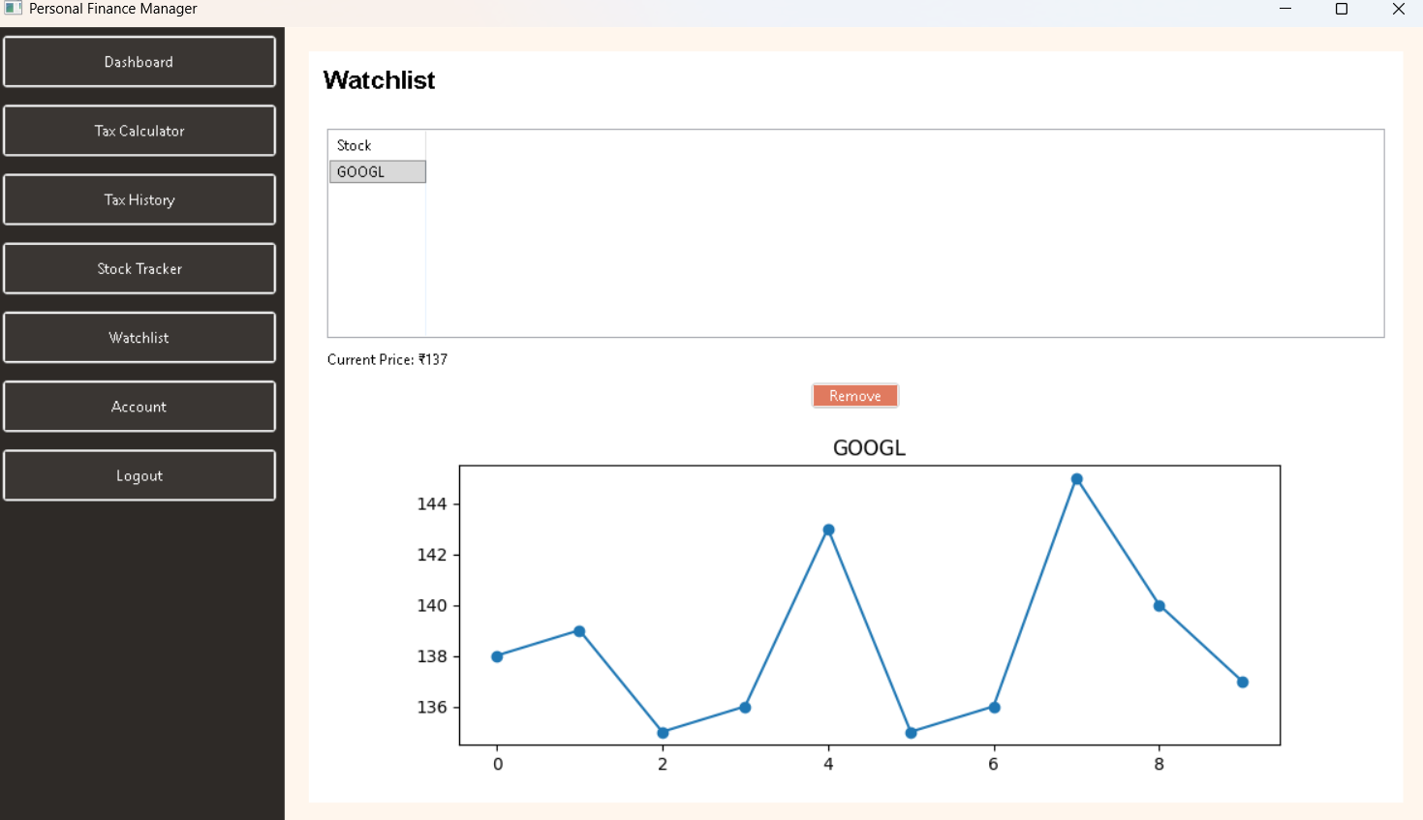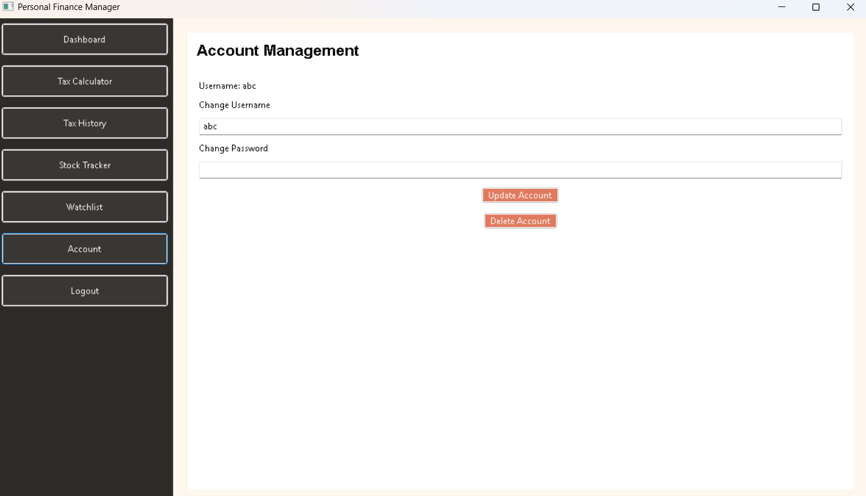
GITHUB – LINK: https://github.com/akshayswamysb-15/Finance-Management-Stock-Tracker

